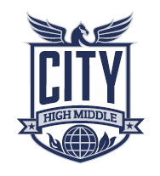
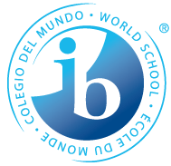

The Nature of CAS
CAS is at the heart of the Diploma Programme. With its holistic approach, CAS is designed to strengthen and extend students’ personal and interpersonal learning from the PYP and MYP.

Creativity

Exploring and extending ideas leading to an original or interpretive product or performance or experience.

Students will engage in experiences that involve creative thinking that must be linked to one or more of the Learning Outcomes. Students can explore creativity in the school, community, as an individual or in a group setting.

Creativity may include visual arts, performing arts, writing, music, design, crafts, culinary arts and any other experience exploring creative outlets.

Activity

Physical exertion contributing to a healthy lifestyle

Students will engage in experiences that require physical exertion that must be linked to one or more of the Learning Outcomes. Students can explore activity in the school, community as an individual or in a group setting

Activity experiences may include individual and team sports, aerobic exercise, dance, outdoor recreation, fitness training, and any other physical exertion leading to a healthy lifestyle.

Service

Volunteer opportunities that meet identified individual and community needs

Students will explore unpaid experiences to help others or make improvements in their community that must be linked to one or more of the Learning Outcomes. Students are encouraged to pursue activities representative of their passions and interests, and may lead to personal growth.

Service experience may include working with school or community groups, fundraising, direct and indirect action, while thinking globally and acting locally.

CAS Stages

- Investigation: Identify your interests, find a cause, and determine community
need.
- Preparation: What skills will you need? Create a plan of action.
- Action: Consider the four types of action. Which one will you do? Why?
- Reflection: How did this service activity connect to one or more of the seven
learning outcomes.
- Demonstration: Find opportunities to present accomplishments to school and
greater community.
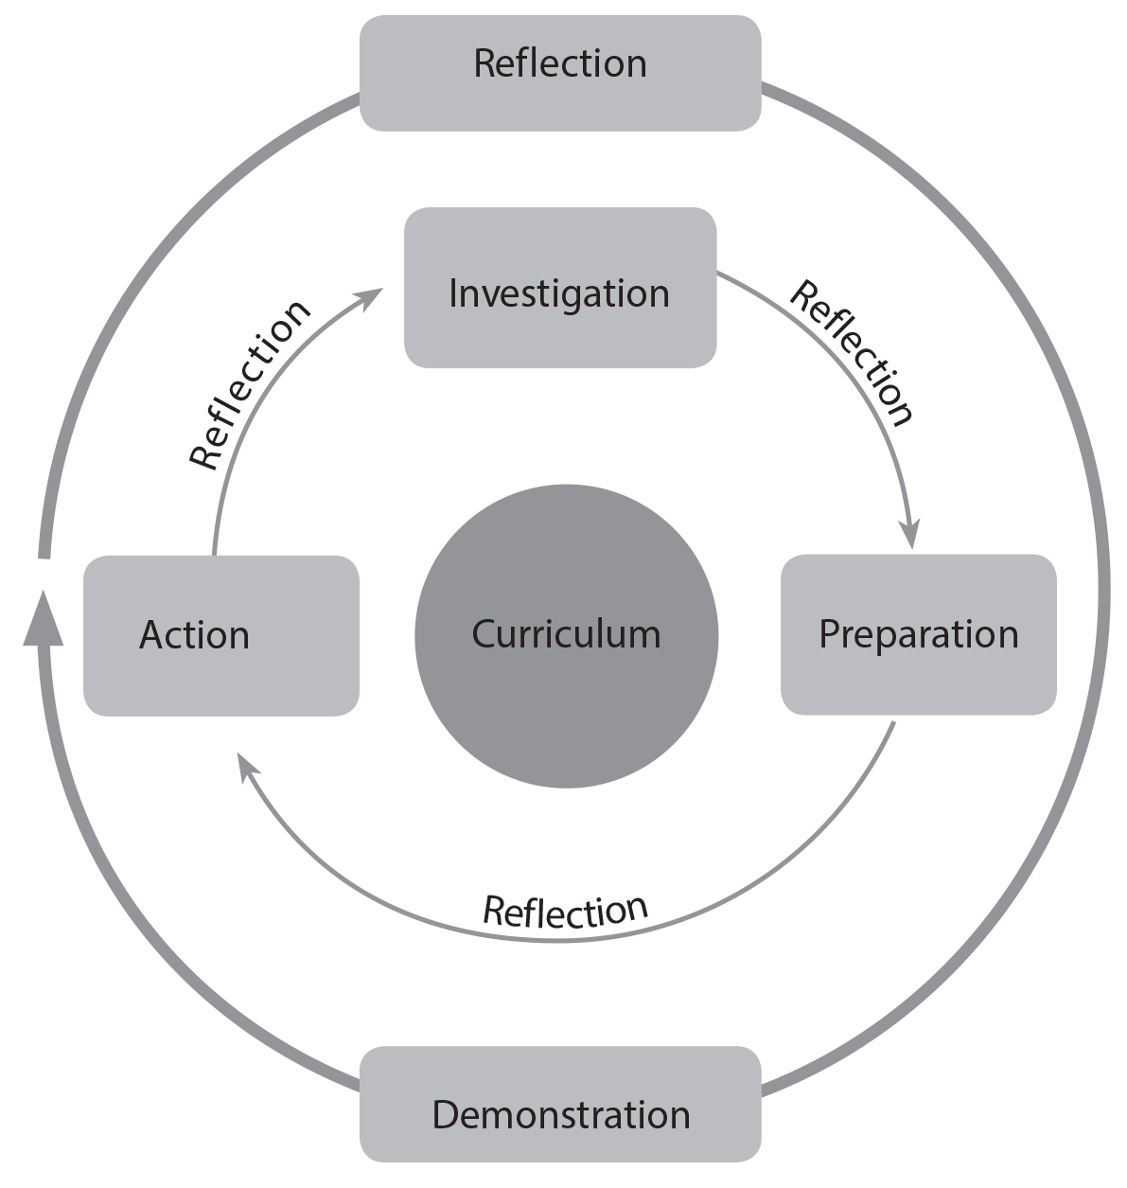
Hours

The CAS programme formally begins at the start of the Diploma Programme and continues regularly, ideally on a weekly basis, for at least 18 months with a reasonable balance between creativity, activity, and service. City is requiring that students complete 8-10 hours each month while in the Diploma Programme. Completion of hours will be reviewed the first Thursday of every month with the exception of September.
In regards to social activities at City, students will be expected to have fulfilled the minimum requirement of 8 hours all months prior to the event.
Students will have to complete hours: 8-10 hours each month of the academic school year and 8-10 total throughout the summer months between junior and senior year; hours should sample from the 3 strands of CAS.
CAS Hour forms are available on CHMSIB.COM. You must be signed into your student google account in order to submit.

Portfolio

All CAS students are expected to maintain and complete a CAS portfolio as evidence of their engagement with CAS. CAS portfolios are housed in a student’s school google account. The portfolio consists of hour submission confirmations, CAS reflections, CAS project form, and any evidence students choose to include for CAS experiences.

CAS Project

Students undertake a CAS project of at least one month’s duration that challenges students to show initiative, demonstrate perseverance, and develop skills such as collaboration, problem-solving, and decision-making.

The CAS project can address any single strand of CAS, or combine two or all three strands.

Students use the CAS stages (investigation, preparation, action, reflection and demonstration) as a framework for CAS experiences and the CAS project.

Interviews

There are three formal documented interviews students must have with their CAS coordinator (either Mrs. Vecziedins or Mrs. Burke).

The first interview is at the beginning of the CAS programme, the second at the end of the first year, and the third interview is at the end of the CAS programme, prior to spring examinations.

CAS Reflections

Students may reflect on a specific CAS experience, a CAS strand, or a Learning Outcome

Students will have one week to complete a reflection. They can complete a written reflection in class (paragraph, poem, etc), or they can complete a reflection through a piece of artwork or an audio or media file. No matter how the reflection is completed, students MUST be able to show their 8th hour teachers that they have uploaded a reflection the 2nd 8th hour of the month.

Students will be required to have 20 reflections.
Scheduled:
Junior year- October-May (8- in 8th hour)
Senior year- October-April (7- in 8th hour)

Unscheduled- these are reflections on their own:
Throughout junior and senior year- 5

CAS learning outcomes
Student completion of CAS is based on the achievement of the seven CAS learning outcomes realized through the student’s commitment to his or her CAS programme over a period of 18 months.
LO 1 | Identify own strengths and develop areas for growth
Descriptor | Students are able to see themselves as individuals with various abilities and skills, of which some are more developed than others.
LO 2 | Demonstrate that challenges have been undertaken, developing new skills in the process
Descriptor | A new challenge may be an unfamiliar experience or an extension of an existing one. The newly acquired or developed skills may be shown through experiences that the student has not previously undertaken or through increased expertise in an established area.
LO 3 | Demonstrate how to initiate and plan a CAS experience
Descriptor | Students can articulate the stages from conceiving an idea to executing a plan for a CAS experience or series of CAS experiences. This may be accomplished in collaboration with other participants. Students may show their knowledge and awareness by building on a previous experience, or by launching a new idea or process.
LO 4 | Show commitment to and perseverance in CAS experiences
Descriptor | Students demonstrate regular involvement and active engagement in CAS.
LO 5 | Demonstrate the skills and recognize the benefits of working collaboratively
Descriptor | Students are able to identify, demonstrate and critically discuss the benefits and challenges of collaboration gained through CAS experiences.
LO 6 | Demonstrate engagement with issues of global significance
Descriptor | Students are able to identify and demonstrate their understanding of global issues, make responsible decisions, and take appropriate action in response to the issue either locally, nationally or internationally.
LO 7 | Recognize and consider the ethics of choices and actions
Descriptor | Students show awareness of the consequences of choices and actions in planning and carrying out CAS experiences.

CHMSIB.COM
All documents related to CAS can be found on the CHMSIB.COM Website, under the DP CAS tab. These resources include:
- Online DP CAS submission form
- CAS Profile Sheet
- CAS Project Form
- CAS Portfolio Inventory Sheet
- CAS Handbook

Appendix A

CAS project
CAS students must be involved in at least one CAS project during their CAS programme.
A CAS project involves collaboration between a group of students or with members of the wider community. Students work as part of a team, with all members being contributors. A CAS project offers students the opportunity to be responsible for, or to initiate, a part of or the entire CAS project. Working collaboratively also provides opportunities for individual students to enhance and integrate their personal interests, skills and talents into the planning and implementation of CAS projects.
All CAS projects should use the CAS stages as a framework for implementation to ensure that all requirements are met.
A CAS project can address any single strand of CAS, or combine two or all three strands. The following examples are provided to help generate further ideas without limiting the scope and direction of a CAS project.
- Creativity: A student group plans, designs and creates a mural.
- Activity: Students organize and participate in a sports team including training sessions and matches against other teams.
- Service: Students set up and conduct tutoring for people in need.
- Creativity and activity: Students choreograph a routine for their marching band.
- Service and activity: Students plan and participate in the planting and maintenance of a garden with members of the local community.
- Service and creativity: Students identify that children at a local school need backpacks and subsequently design and make the backpacks out of recycled materials.
- Creativity, activity, and service: Students rehearse and perform a dance production for a community retirement home.
A minimum of one month is recommended for a CAS project, from planning to completion. CAS projects of longer duration can provide even greater scope and opportunities for all participants and should be encouraged.
Before completing your CAS Project, it will be important to get the CAS Project Document, to record the project. This is NOT the same as the recording sheet that you normally use for CAS hours.

Appendix B

Reflection
One way to explain reflection is to clarify what reflection is and what it is not. A helpful way to initiate discussion of the reflective process is for students to collaborate with their peers and draw up their own comparison table. This chart shows examples of what students may list and discuss.
Reflection is: | Reflection is not:
- honest  - personal  - done in many different ways  - sometimes difficult  - sometimes easy  - sometimes creative  - building self-awareness  - necessary for learning  - what I did, combined with how I felt  - surprising  - helpful for planning  - done alone or with others  - about thoughts, feelings, and ideas  - adding perspective. | - forced  - right or wrong  - good or bad  - marked or graded  - difficult  - copying what someone else said  - predictable  - to be judged by others  - only a summary of what happened  - done to please someone else  - a waste of time  - only written  - only discussion  - only led by teachers.
Appendix C

CAS portfolio
All CAS students are expected to maintain and complete a CAS portfolio as evidence of their engagement with CAS and achievement of the seven CAS learning outcomes.
Profile: In this section, students include their interests, skills and talents, plans and goals for their CAS programme. At the start of CAS, students map their interests against the three strands of CAS to identify possible CAS experiences.
Experiences: in this section, students will keep a log of their CAS experience submissions, with a copy of the submitted google form.
Evidence: In this section, will include evidence, such as, planning documents, letters, emails, certificates, acknowledgments of participation and achievements, photographs, videos, and so on.
Reflections: in this section, students will include 20 reflections that have been completed throughout the course of their two years in the Diploma Programme.

